Pairs Trading via Cointegration & Z-Score Signals

Author: HARSH BYJASH | Date: 2025-10-01

# 1. Objective

Demonstrate a statistical arbitrage approach by identifying a cointegrated pair, constructing a spread, and trading mean reversion using z-score thresholds.

# 2. Data

Synthetic cointegrated prices for two assets (X, Y) from 2020–2024. File: data/cointegrated_pair.csv

# 3. Method

Estimated beta with OLS (Y ~ beta*X). Computed spread = Y - beta*X, standardized via a 60-day rolling z-score. Entered long spread when z < -2, short when z > +2; flattened when |z| < 0.5. Approximated PnL with returns of (Y - beta*X).

# 4. Results

|  |  |  |  |
| --- | --- | --- | --- |
| CAGR | Vol | Sharpe | MaxDD |
| 0.57% | 2.51% | 0.23 | -3.29% |

Figures:

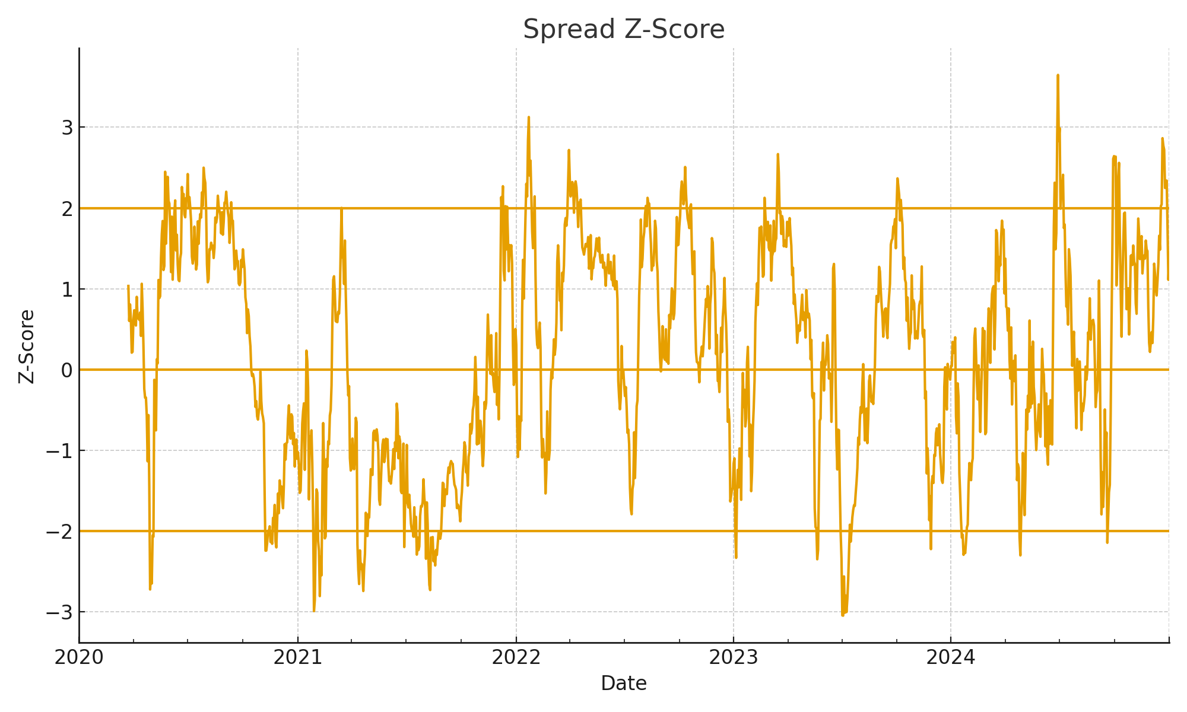

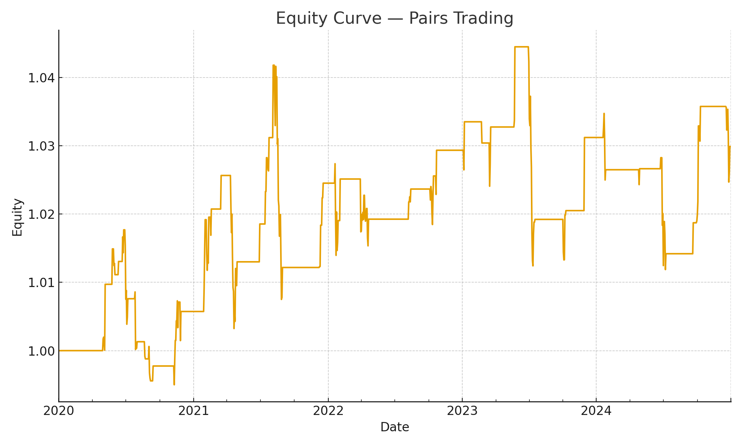

# 5. Interpretation

The z-score entry/exit rules captured mean-reversion episodes in the synthetic pair. Performance depends on stability of cointegration and thresholds; turnover and execution costs will reduce results.

# 6. Limitations

Synthetic data and simplified execution. Real-world pairs require rolling beta, stationarity tests, and transaction cost modeling.

# 7. Next Steps

Test on real pairs (e.g., KO/PEP, XOM/CVX), add rolling regression, include hard stops, and run out-of-sample walk-forward validation.